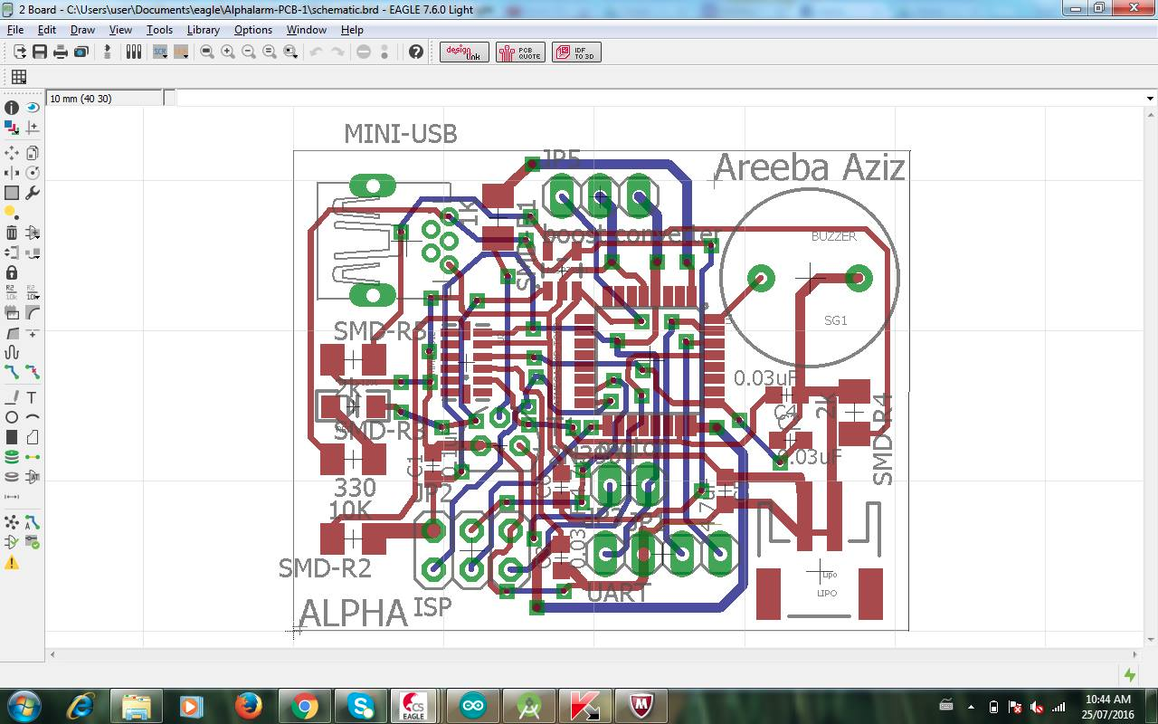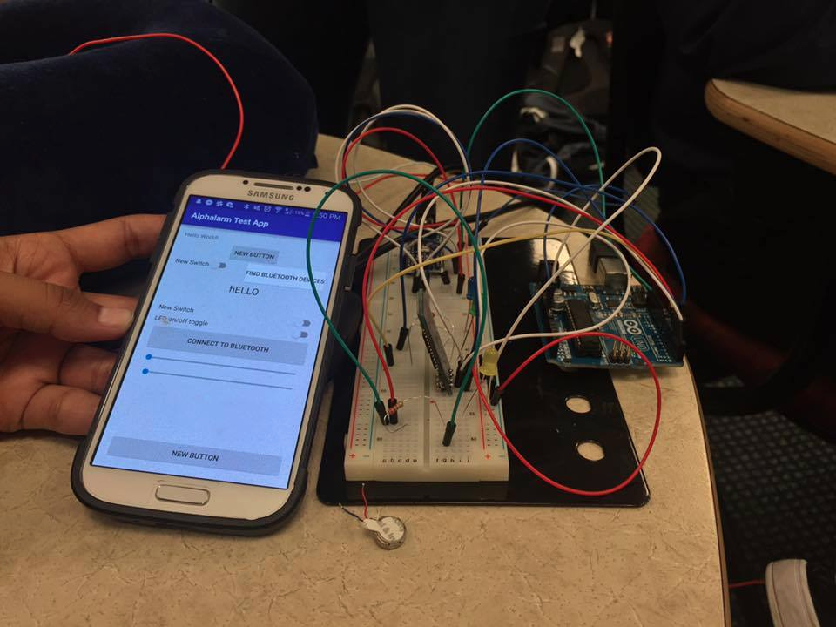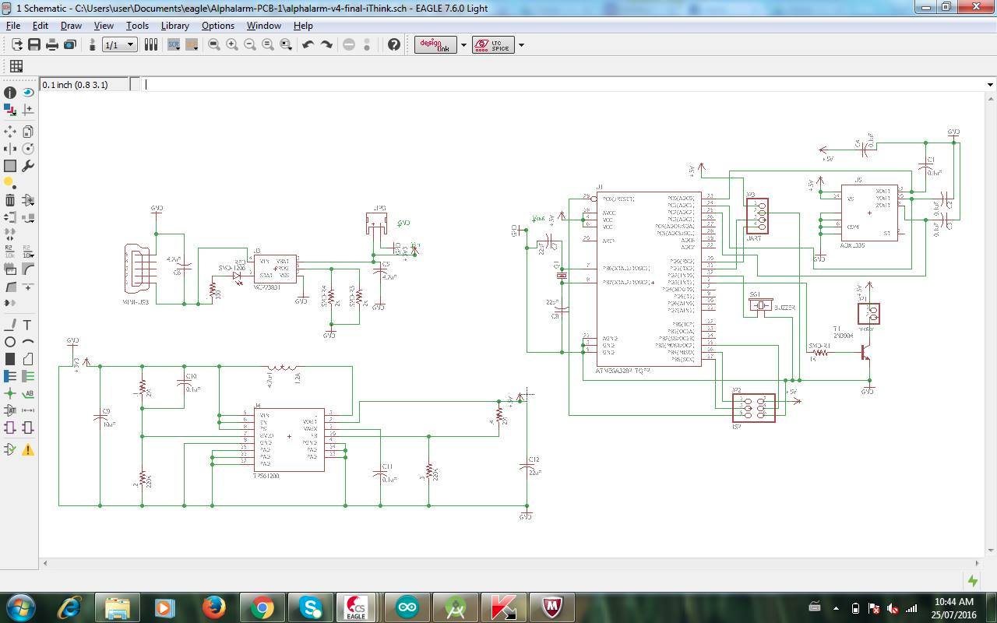

Alpha Technologies

+

lorem ipsum

Official Website:

alphalarm.com

Facebook Page:

https://www.facebook.com/alphalarm/

Join Us Now:

http://alphatechnologies.webflow.io/mailing-list